Theory of Knowledge Exhibition

# *Why do we seek knowledge?*

# 

# 

### Student code: lsh546

**Word count: 950**

### **Introduction**

For my TOK Exhibition, I will answer, “Why do we seek knowledge?”. This question will be answered using the James Webb Space Telescope, the Rosetta Stone, and my physics book as evidence.

### Object 1: James Webb Space Telescope: curiosity

Curiosity has always been a driving force for our survival and evolution. The James Webb Space Telescope is a great example of our desire to understand the world around us and our curiosity about the unknown. The JWST was initially designed as a successor to the Hubble Space Telescope. It is located at the Lagrange point L2, 1.5 million km from the Earth[1]. Thanks to its infrared sensors, the JWST can "see" through clouds of gas and dust at 13.7 billion light-years away[2], almost to the beginning of the universe, considering that the universe is ± 13.7 billion years old[3].

The JWST, a next-generation space telescope created to understand the universe, illustrates our intrinsic need to acquire knowledge. Despite its innovations, massive investment of over $10 billion, and creation time of more than 30 years, the telescope demonstrates one of mankind's main driving forces behind seeking knowledge: curiosity.

Its technology and capabilities, with significantly longer wavelengths, enable Webb to look much closer to the universe's beginning, hunt for the unobserved formation of the first galaxies, and look where stars and planetary systems are forming today. The JWST has found a galaxy in the early universe that is so massive that it shouldn't exist (JWST 7329), thus challenging a widely accepted physical model that challenges the standard cosmological model based on dark matter. This pursuit of knowledge follows a format that is not limited to discovery within the scientific field; it gives a collective desire of man to explore the unknown[4].

Additionally, allocating resources to such projects, like the JWST, signifies a greater emphasis on exceeding human knowledge limits by contributing to innovation and encouraging younger researchers. Developing such a telescope has involved scientists, engineers, and organizations from across the globe in collaborative efforts to expand knowledge about the universe. JWS is an example of how men, driven by curiosity and seeking knowledge, persistently overcome challenges in pursuit of understanding and progress.

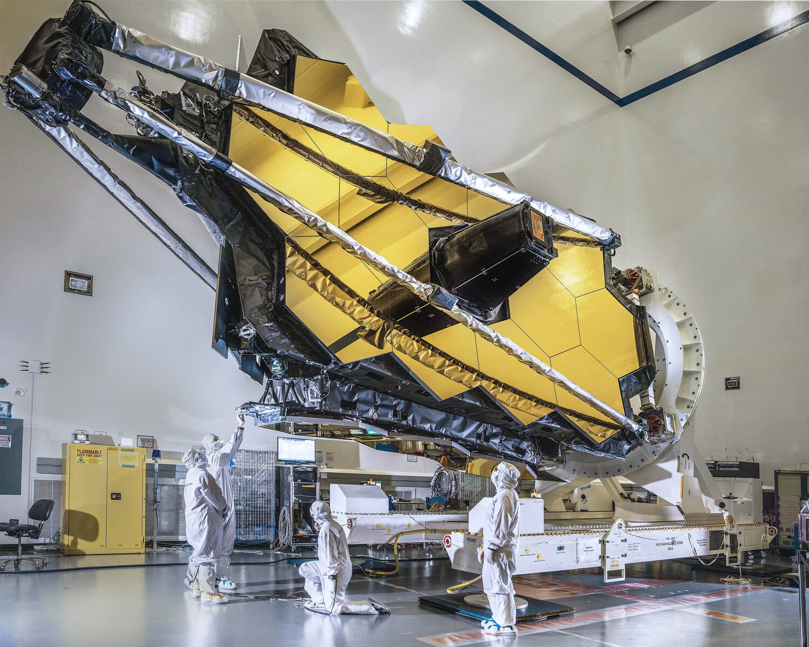  
*James Webb Space Telescope (Credit:* [*Chris Gunn*](https://www.chrisgunn.com/portfolio/s9n5odppr46jr161zqyh2ezf1dtgfk)*)*

### **Object 2: - Rosetta Stone: showcases the need to understand our past**

The Rosetta Stone is an essential historical symbolic figure because it represents humanity's quest to understand and connect with its past by breaking down lost languages. The Rosetta Stone stands as a symbol of our instinct and even need to learn the history of our species. While it turned up in 1799 during Napoleon's campaign in Egypt, it has been revealed to be the vital finding in understanding ancient Egyptian hieroglyphs[5]. However, the greatest minds of the times had puzzled over those complex signs without comprehending their true meanings. Nonetheless, the Rosetta Stone, which had a trilingual inscription including hieroglyphs, demotic text, and Greek language, enabled the Egyptologists to discover the hieroglyphic writings[6].

However, this historical item makes it evident that breaking the walls of ignorance regarding our past is pivotal. Through the ability to decrypt the hieroglyphs, historians could gain an in-depth understanding of the beliefs, customs, and accomplishments of ancient Egyptian culture. This discovery enriched our knowledge of history and led us to re-evaluate our understanding of human progress up to the present day.

The Rosetta Stone is a perfect example for those who research and explore our history to understand how our values have changed and developed throughout time. It emphasized our curiosity-driven exploration, with, of course, the final act of discovering and interpreting ancient items, increasing the depth of our connections with societies that existed in the past.

The Rosetta Stone demonstrates our natural desire for historical knowledge. Pursuing this goal is not only a way of deepening our knowledge of earlier civilizations but also a tool for understanding different cultures, not repeating the negatives of the past, and drawing inspiration from the positives, too.

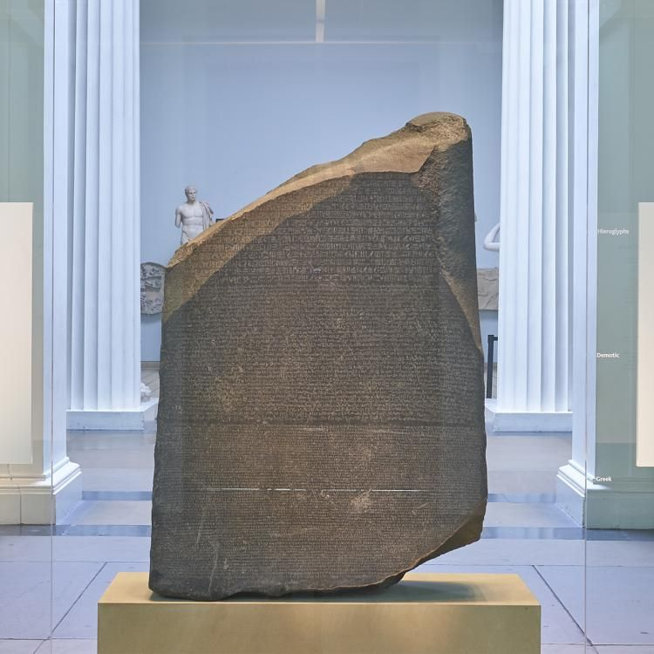   
*Rosetta Stone in the* [*British Museum*](https://www.britishmuseum.org/blog/everything-you-ever-wanted-know-about-rosetta-stone)

### **Object 3: My Physics Book: personal benefits**

My dream is to become a mechanical engineer, and my pursuit of knowledge is driven not only by my interest but also by personal and professional benefits, such as excelling in the IB and succeeding in my future mechanical engineering studies. My physics book is a key point in my quest to acquire knowledge about becoming a mechanical engineer. The book of physics I use is an essential element for preparing for the tests and a source of necessary knowledge, formulas, and problem-solving techniques, which are important for academic achievement, which is my interest. Aside from just helping with schoolwork, gaining this basic knowledge will prepare me for engineering, scientific, and technical work.

Through my learning of physics and other subjects, I'm preparing myself to play a part in developing solutions that will hopefully have a major impact on the world. This goal is one of the reasons why we, as human beings, seek to gain knowledge, which opens the way to other achievements such as breakthroughs, solving concrete problems, and improving and advancing the world. Something I love about physics is that I can apply some of the knowledge I’ve learned through my scholarship to the real world. When I get home on my electric scooter, I usually try to visualize the physics happening when riding. For example, when I turn, brake, or simply accelerate, I’m trying to guess the force applied on the wheels or the ground. Applying knowledge to the real world is the most satisfying part of learning and is not specific to physics.

Finally, my physics book is much more than just methods for passing exams. It's also a way of building that knowledge to become the best mechanical engineer I can be or even a source of personal and professional satisfaction (one often goes with the other). This shows how crucial personal benefit is for the seeking of knowledge.

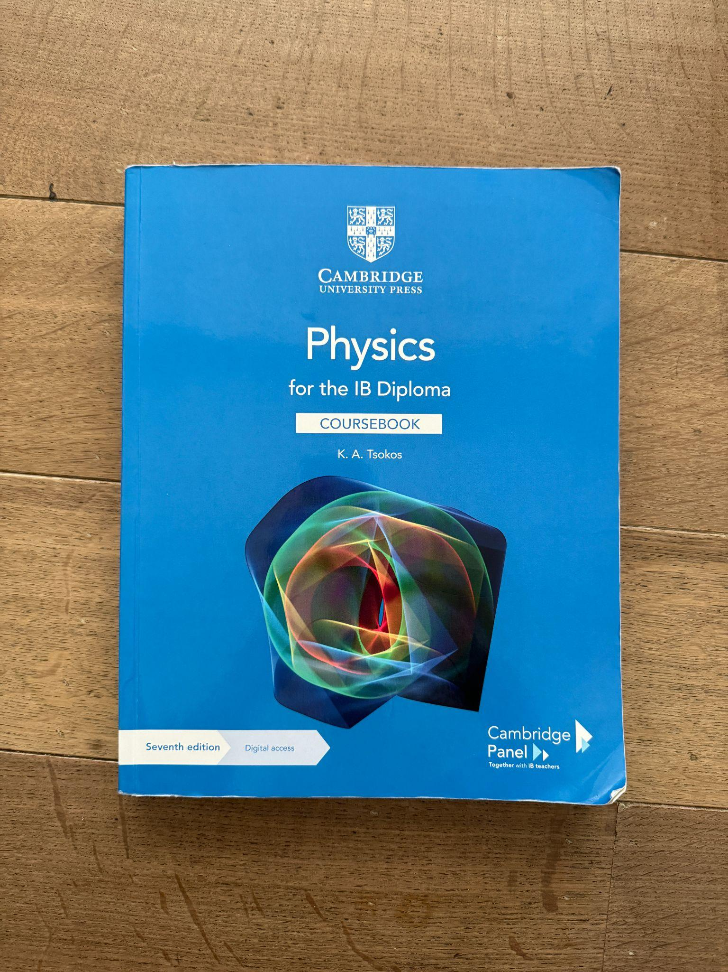   
*My physics book in my room*

### Works Cited

Cesari, T., & Center, Nasa. G. S. F. (2021, July 17). Preparing for Webb Launch: Testing Progress Continues for the Most Powerful Space Science Telescope Ever Built. SciTechDaily. https://scitechdaily.com/preparing-for-webb-launch-testing-progress-continues-for-the-most-powerful-space-science-telescope-ever-built/

Chris Gunn Portfolio. (n.d.). Chris Gunn. Retrieved April 21, 2024, from https://www.chrisgunn.com/portfolio/s9n5odppr46jr161zqyh2ezf1dtgfk

Howell, E. (2022, March 30). How the James Webb Space Telescope’s infrared detectors will open new vistas in astronomy. Space.com. https://www.space.com/james-webb-space-telescoe-infrared-light-astronomy-vistas-video

Hughes, A. (2022, July 14). James Webb Space Telescope: Everything you need to know about the first images. BBC Science Focus Magazine. https://www.sciencefocus.com/space/james-webb-space-telescope

Imagine the Universe! (n.d.). Imagine.gsfc.nasa.gov. https://imagine.gsfc.nasa.gov/science/featured_science/tenyear/age.html#:~:text=Before%201999%2C%20astronomers%20had%20estimated

Orbit - Webb/NASA. (n.d.). Webb.nasa.gov. https://webb.nasa.gov/content/about/orbit.html#:~:text=The%20James%20Webb%20Space%20Telescope

Roulette, J. (2021, December 25). A costly and difficult path to the launchpad. The New York Times. https://www.nytimes.com/2021/12/25/science/webb-telescope-cost.html

Swinburne University of Technology, S. U. of. (2024, February 16). “Beyond What’s Possible” – Webb Space Telescope Discovers Mysterious Ancient Galaxies. SciTechDaily. https://scitechdaily.com/beyond-whats-possible-webb-space-telescope-discovers-mysterious-ancient-galaxies/

The British Museum. (2017, July 14). Everything you ever wanted to know about the Rosetta Stone. The British Museum. https://www.britishmuseum.org/blog/everything-you-ever-wanted-know-about-rosetta-stone

The Editors of Encyclopaedia Britannica. (2019). Rosetta Stone | ancient Egyptian inscribed stone. In Encyclopædia Britannica. https://www.britannica.com/topic/Rosetta-Stone

1. Orbit - Webb/NASA. (n.d.). Webb.nasa.gov. https://webb.nasa.gov/content/about/orbit.html#:~:text=The%20James%20Webb%20Space%20Telescope
2. Imagine the Universe! (n.d.). Imagine.gsfc.nasa.gov. https://imagine.gsfc.nasa.gov/science/featured_science/tenyear/age.html#:~:text=Before%201999%2C%20astronomers%20had%20estimated
3. Howell, E. (2022, March 30). How the James Webb Space Telescope’s infrared detectors will open new vistas in astronomy. Space.com. https://www.space.com/james-webb-space-telescoe-infrared-light-astronomy-vistas-video
4. Swinburne University of Technology, S. U. of. (2024, February 16). “Beyond What’s Possible” – Webb Space Telescope Discovers Mysterious Ancient Galaxies. SciTechDaily. https://scitechdaily.com/beyond-whats-possible-webb-space-telescope-discovers-mysterious-ancient-galaxies/
5. The British Museum. (2017, July 14). Everything you ever wanted to know about the Rosetta Stone. The British Museum. https://www.britishmuseum.org/blog/everything-you-ever-wanted-know-about-rosetta-stone
6. The Editors of Encyclopaedia Britannica. (2019). Rosetta Stone | ancient Egyptian inscribed stone. In Encyclopædia Britannica. https://www.britannica.com/topic/Rosetta-Stone